

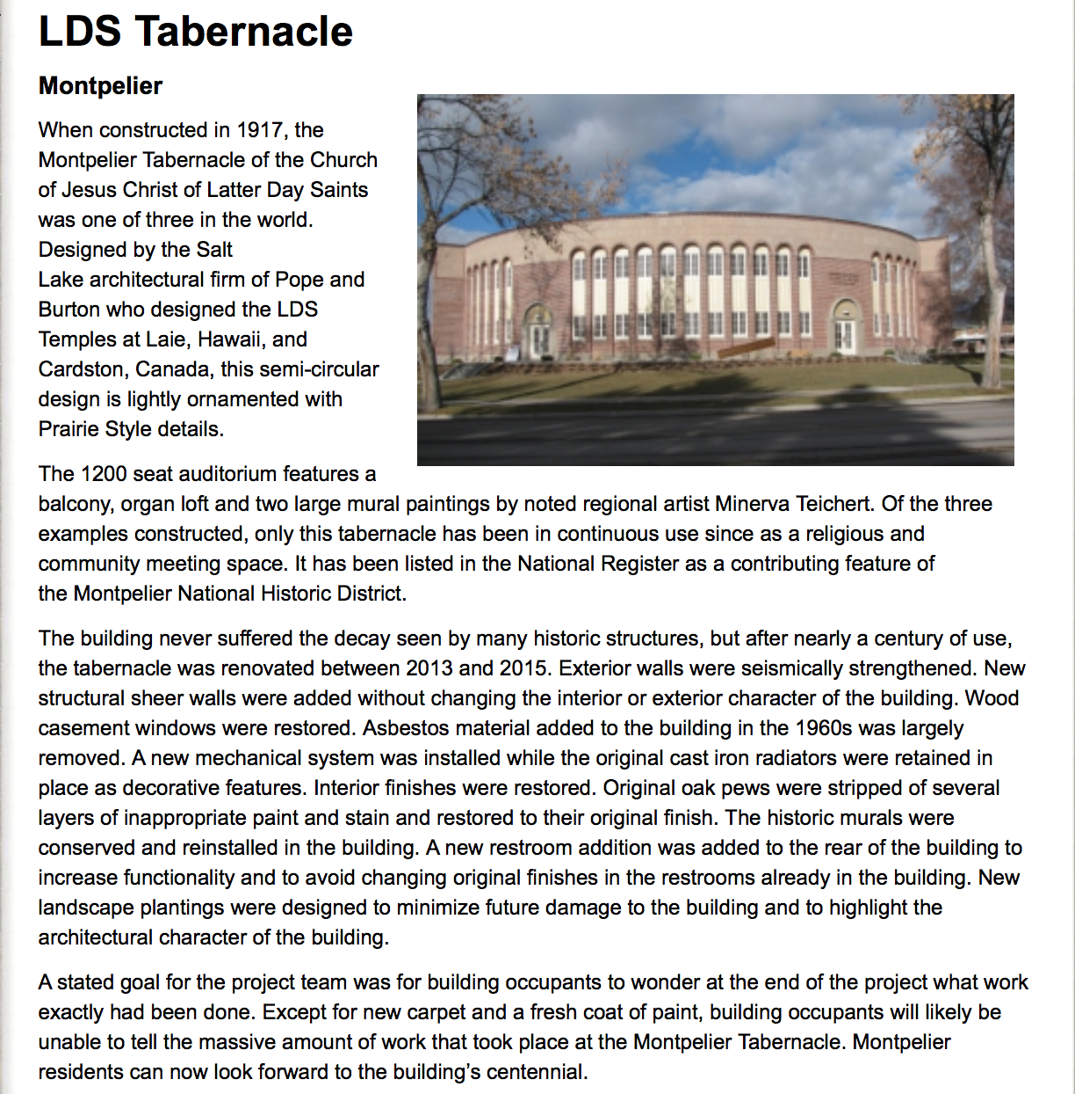

<http://preservationidaho.org/programs/orchids-onions/2015/lds-tabernacle>