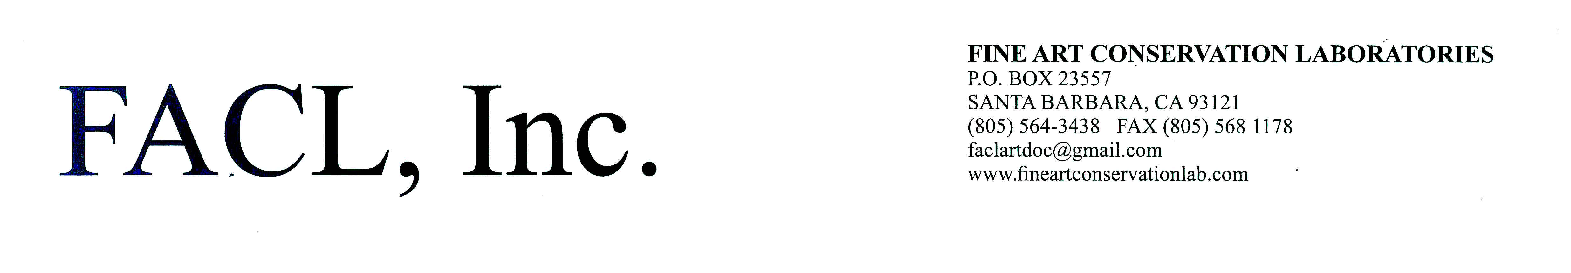

Virginia Panizzon

P.O. Box 23557 Santa Barbara, CA 93103

Lab: 805-564-3438 Cell: (805) 259-5737

Email: vivi.decor@gmail.com

|  |  |
| --- | --- |
|  |  |
|  | **Experience**  **FACL Inc. 1994 - 1996, 2002 - present**   * Painting Conservator at Fine Art Conservation Laboratories in Santa Barbara, California. Facility specializes in the conservation of easel paintings (panel, fabric), murals (affresco, tempera, oil), works of art on paper and period frames. FACL, Inc. performs services for clients throughout the United States. The moveable artwork is treated in the 5000 sq. ft. Santa Barbara laboratory. On-location projects (murals, surveys) are performed each year. * Services offered include: All painting conservation treatments, an extensive amount of consultation work including collection surveys, authentication studies, expert witness services.   **Etoile Srl. and Laura Franchi Interni Studio, Italy 1995-2001**   * Design work and decorative finishes, restoration of old wall paintings and decorative finishes, project planning, project preparations * 7 yrs working under the direction of professional interior designer and architect Laura Franchi. Both on site and studio work for her companies Etoile srl. followed by, Laura Franchi Interni Studio, Bedizzole, BS, Italy |
|  | **Education** |
|  | 8+ year full time apprenticeship at Fine Art Conservation Laboratories in painting conservation, working in-laboratory on easel paintings and on-site mural projects. Daily treatments and tasks were performed under professional art conservator supervision, intensive instruction, and hands-on experience. In all treatments and aspects of painting conservation. See a testimonial video from an FACL client: <https://www.youtube.com/watch?v=WWtPDRg24Z0>  Post – graduate training in Italy: Restoration and execution of decorative arts: Various wall painting techniques, working on site throughout Italy. Developing an acute sense for color and design. Diverse knowledge and ability for paintings any surface.  **Continuing Education**  - Attended “Advanced Career Inpainting Workshop” at the Campbell Center in Mt Carroll, IL – American Institute for the Conservation of Historic and Artistic Works  - Attended two specialized training workshops for Art Conservation at the Getty Conservation Institute, Los Angeles, CA. Workshop subjects were:  - Tear repair for paintings: <https://www.youtube.com/watch?v=Xhhu0AZ_WVI>  - Advanced aqueous cleaning techniques (for paintings)  - Attended specialized alternative lining technique workshop in Skaneateles, NY: Organized by the American Institute for the Conservation of Historic and Artistic Works  **Special On Site Projects with FACL, Inc.** |

* On-site restoration and conservation of 7,800 sq. ft. of murals: Fair Park, Dallas, TX: <http://www.FairParkMurals.com>
* On-site removal, restoration, conservation, and installation of murals: City Of Burbank, CA Police Dept. and Fire Dept.
* On-site restoration of murals: City of Oxnard, CA
* Removal of Piazzoni and Dumond murals for Asian Art Museum from the Old Main Library. San Francisco, CA. Re-adhesion to panels for installation in De Young Museum.
* Restoration and Conservation of the painted cupola, ceiling, and walls in the formal dining wing of the Krocker Estate, on Pescadero Point. Pebble Beach, CA
* Corporation of the President cycle of 25 murals for North Visitors Center, SLC, UT
* Produce Market, Los Angeles – 2 monumental murals by Tom Suriya: <http://www.fineartconservationlab.com/la-produce-market-murals>
* Murals in Los Angeles by Kent Twitchell, worked on Bob Hope Patriotic Hall, Biola Jesus and 7th St Alterpiece: <https://www.youtube.com/watch?v=WWtPDRg24Z0>

**Special Projects in Italy**

*Hotel Pantheon, Rome, Italy – Mural restoration and decoration in the historic center, Rome, next to the Pantheon.

* Decorative fresco-like band on canvas adhered to wall against ceiling in lobby. Private residence, murals and decorative finishes in 17 century historic villa, Vicenza, Italy

|  |
| --- |
| *Residential village **(123 units),** Porto Rotondo, Sardegna, Italy  * Private 17th century murals in historic residence, Barcuzzi (Garda Lake), BS, Italy  * Faux finish throughout, decorative motifs in kitchen, hallways, sauna room, indoor pool room - Iseo Lago Hotel and Restaurant  *Faux finish to selected walls in entrance and lobby - Albergo Alleluja, Punta Ala, Tuscany, Italy  *Worked along side various freelance artists assisting in large scale new murals in private homes, restaurants, discotechs, and breweries, throughout Northern Italy. |