2012 Workshop Resources

Search Stories Video Creator - Google App Engine
Make Free Videos From Search Results
https://searchstories-intl.appspot.com/en-us/creator/

Animoto Tutorial
http://www.youtube.com/watch?v=FamyvqIgjOQ
Make free videos from photos (free)
Click HERE to go to Animoto

Upload Videos to Multiple Sites –
Automation - Free
http://www.oneload.com

Using Facebook for Business
Free
http://www.facebook.com/business/howitworks/

Search Engine on LinkedIn
Free
http://www.linkedin.com/search?trk=msitebd

Easy Video Creation Training Series
Colin Martin and Marc Bullard
Click here for training series information

Information on Creating a WordPress Blog
Great Internet Marketing – Tom Antion –
Click here for WordPress creation training info

Training on Public Speaking
Media training for your presentations –
workshops, radio and TV interviews
Click here for Tom Antion’s training on professional public speaking
(He’s very famous for this)

Instruction Books for Training:
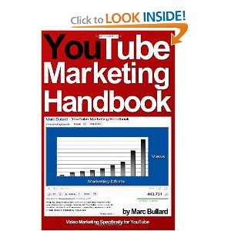
“YouTube Marketing Handbook” by Marc Bullard
Click here for the author’s website
Click here to see the book on Amazon

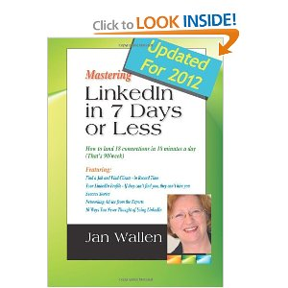
“Mastering LinkedIn In 7 Days Or Less” by Jan Wallen
Click here for the author’s website
Click here to see the book on Amazon

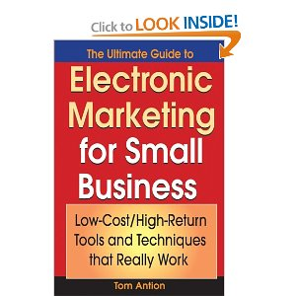
“The Ultimate Guide To Electronic Marketing For Small Business: Low-Cost/High Return Tools And Techniques That Really Work” by Tom Antion
Click here to see the book on Amazon

The following book doesn’t have anything to do with the Internet… but it is a very interesting, a fast read and out of the box thinking about “outreach” and changing your attitude. I am now giving a try of what this book suggests and enjoying the process.

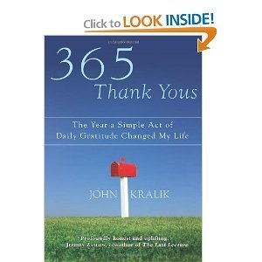
“365 Thank Yous: The Year A Simple Act Of Daily Gratitude Changed My Life” by John Kralik
Click here to see the book on Amazon

“The more you recognize and express gratitude for the things you have, the more things you will have to express gratitude for.” Zig Ziglar

